
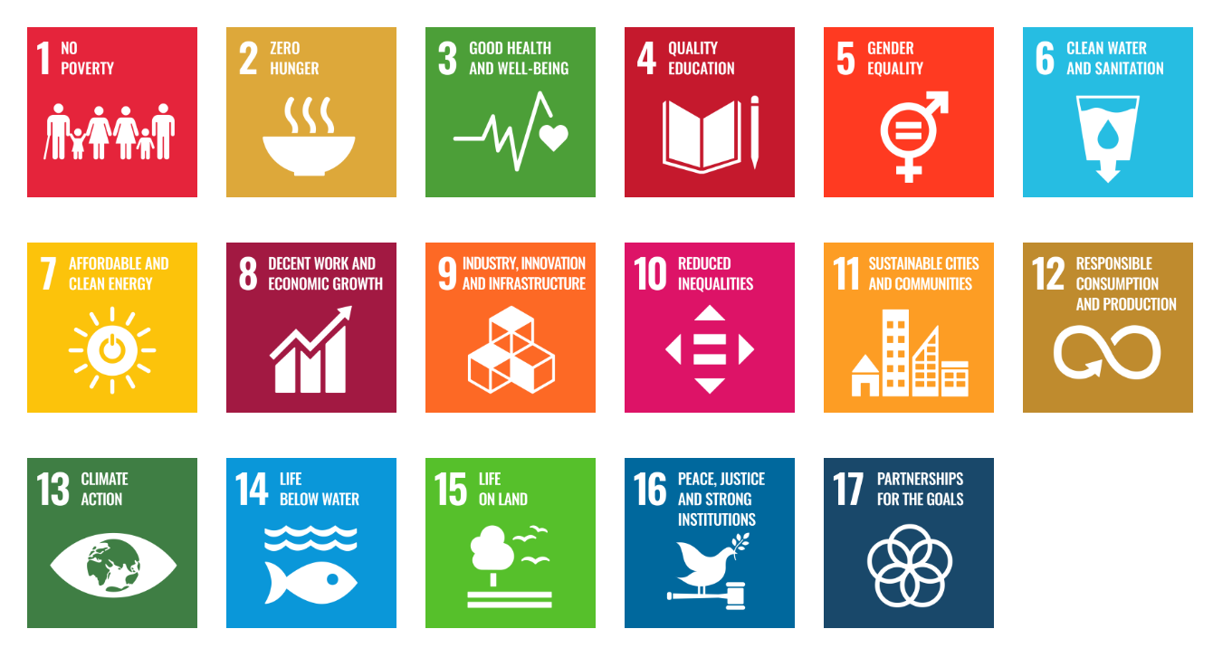

TEMPLATE FOR
THE INTEGRATION OF SDGs IN CURRICULA

Are you ready to make a difference in your academic work and contribute to the Sustainable Development Goals (SDGs)?

Take a moment to reflect on how you can contribute to all or some of the SDGs through your academic work. The following template aims at helping you to frame your contribution to the SDGs according to the TSC model (Granados-Sánchez, 2022). The description of the model is provided in the theoretical document that accompanies this template. This text is a guideline that serves as a catalyst for inspiration and action. The first thing you need to do is to decide the level of transformation of your courses (if you want to adapt, reform or transform them) and the elements you want to start with. Propose suggestions for action and implement them.

TEMPLATE

ELEMENTS | LEVEL OF TRANSFORMATION
ELEMENTS | ADAPTATION | REFORM | TRANSFORMATION
PERSPECTIVE OF SD & SDGs
ESD TYPE
CONTEXT
INSTITUTIONAL INTEGRATION
TYPE OF KNOWLEDGE
LEARNING
TYPE OF CHANGE
THE COMMUNITY

